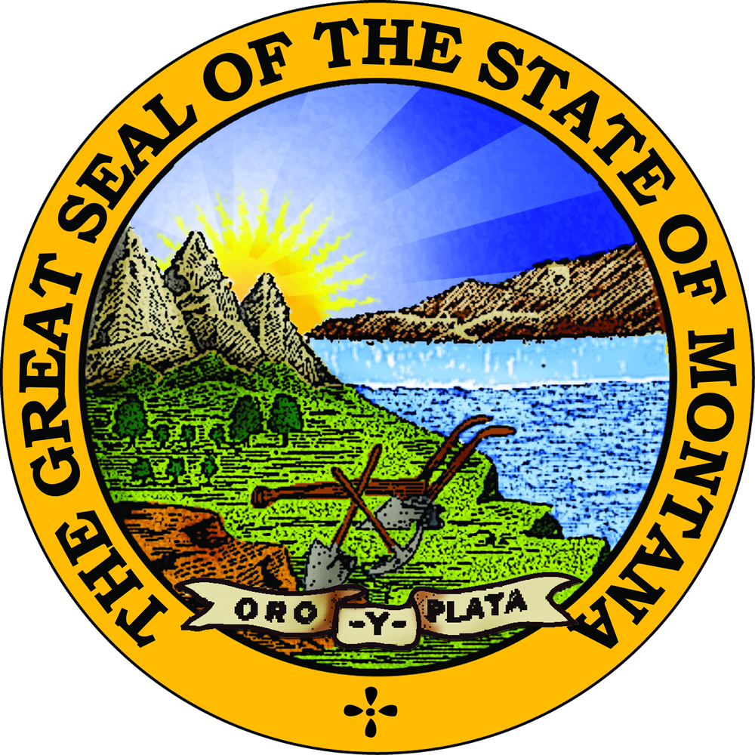
State of Montana • Department of Administration
Division of Banking and Financial Institutions
301 South Park, Suite 316 • PO Box 200546 • Helena, MT 59620-0546
Phone: 406-841-2920 • Fax: 406-841-2930
E-mail: banking@mt.gov • Website: www.banking.mt.gov/mortgage.asp

Mortgage Loan Origination Disclosure

(Name of mortgage loan originator) is a Montana-licensed mortgage loan originator employed by a Montana licensed entity who is authorized to provide mortgage loan origination services to (borrower and co-borrower(s) name – printed) in connection with your Montana residential mortgage loan. Lender(s) whose loan products (name of entity) distributes generally provide their loan products to (name of entity) at a wholesale rate.

SECTION 1. NATURE OF RELATIONSHIP in connection with this mortgage loan:
- (name of entity) is acting as an independent contractor and not as your agent;
- (name of entity) enters into separate independent contractor agreement(s) with one or more lender(s); and
- While (name of entity) seeks to assist you in meeting your financial needs, (name of entity) does not distribute products of every lender(s) or investor(s) in the market and cannot guarantee the lowest price or best terms available in the market.

SECTION 2. OUR COMPENSATION
- The retail price (name of entity) offers you may include (name of licensee's) compensation.
- If you would rather pay a lower interest rate, you may pay higher up-front costs.
- If you would rather pay less up front, you may pay all of (name of entity's) compensation indirectly through a higher interest rate in which case (name of entity) will be paid by the lender.
- If you compensate (name of entity) directly, (name of entity) cannot be compensated by any other person for the same transaction.

By signing below, you acknowledge that you have received a copy of this disclosure.

_______________________________________________________ ___________________________
Borrower Date

_______________________________________________________ ___________________________
Co-Borrower Date

____________________________________ ________________ ___________________________
Mortgage Loan Originator NMLS # Date

_______________________________________________________ ___________________________
Employing Entity NMLS#

The State of Montana, Department of Administration, Division of Banking and Financial Institutions (Division), is the licensing agency of mortgage lenders, mortgage brokers, mortgage servicers, and mortgage loan originators. Any consumer with a comment, question, or concern should contact the Division by the means listed within this disclosure.

